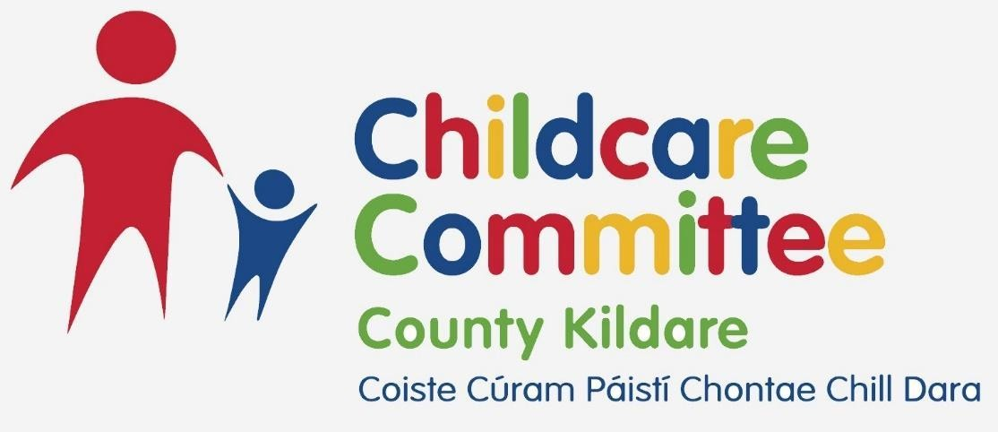

**Annual Report 2023**

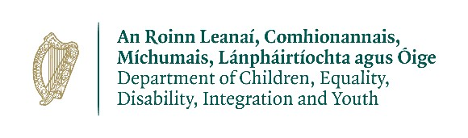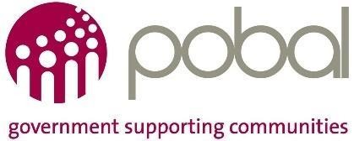

# Contents

Contents .............................................................................................................................................. 1

**Glossary of Terms** ................................................................................................................................... 3

**Company Information** ............................................................................................................................ 6

**A Foreword from our Chairperson**......................................................................................................... 7

**Message from our CEO** ........................................................................................................................... 9

**About Kildare County Childcare Committee**  ...................................................................................... 12

Our Vision .......................................................................................................................................... 12

Our Mission ....................................................................................................................................... 12

Our Values ......................................................................................................................................... 12

Our Board of Directors ...................................................................................................................... 13

Our Funding ...................................................................................................................................... 13

Our Staff ............................................................................................................................................ 13

Our Governance ................................................................................................................................ 13

Our Programme of Work .................................................................................................................. 14

**Strategic Plan KCCC 2023-2026** ............................................................................................................ 15

**Kildare County Childcare 21st Conference** .......................................................................................... 17

**Administration of Government Childcare Schemes** ............................................................................ 18

National Childcare Scheme (NCS) ..................................................................................................... 18

Community Childcare Subvention Plus Programme (CCSP) ............................................................. 18

The Early Childhood Care and Education Programme (ECCE) .......................................................... 18

Access and Inclusion Model Programme (AIM) ................................................................................ 19

Core Funding ..................................................................................................................................... 19

Pobal Compliance ............................................................................................................................. 19

Childcare Service provision: .............................................................................................................. 20

National Aistear Siolta Initiative ....................................................................................................... 21

Quality Support ................................................................................................................................. 21

Children First Training ....................................................................................................................... 22

AIM .................................................................................................................................................... 22

Manager Networks ........................................................................................................................... 23

**2023 Grants** .......................................................................................................................................... 24

The Childminding Development Grant ............................................................................................. 24

The Parent & Toddler Grant .............................................................................................................. 24

Learner Fund Bursary ........................................................................................................................ 25

**Childminder Supports** .......................................................................................................................... 26

National Action Plan for Childminding .............................................................................................. 26 Childminding Training: ...................................................................................................................... 26

Childminding Staffed Local Networks: .............................................................................................. 27

**Communications** ................................................................................................................................... 29

**Events** ................................................................................................................................................... 29

**Recruitment Support** ............................................................................................................................ 29

**Ukraine Support** ................................................................................................................................... 30

**Collaborations with Local and National Networks** ............................................................................. 31

Kildare CYPSC and Kildare County Childcare Committee collaboration ........................................... 34

**Additional Work of KCCC** ..................................................................................................................... 36

**Finance** .................................................................................................................................................. 37

**Board of Directors Report** .................................................................................................................... 39

Board of Directors Attendance 2023 ................................................................................................ 39

KCCC Organisational Structure ......................................................................................................... 40

**Health, Safety and Wellbeing** .............................................................................................................. 40

**Appendices** ........................................................................................................................................... 41

Appendix 1 – **KCCC Organisational Chart 2023** ................................................................................ 41

Appendix 2 – **KCCC Salary Scales** ...................................................................................................... 42

|  |  |
| --- | --- |
| Glossary of Terms | |
| AIM | **Access and Inclusion Model**; AIM is a model of supports designed to ensure that children with disabilities can access the ECCE Programme in mainstream pre-school settings |
| Better Start | **Better Start** National Early Years Quality Development is a national initiative established by the Department of Children, Equality, Disability, Integration and Youth and hosted by Pobal. Better Start promotes quality and inclusion in Early Learning and Care (ELC) settings for children from birth to six years of age in Ireland |
| CAPA | **Corrective Actions and Preventive Actions**; are the defined actions necessary for a Registered Provider to take in order to address the non-compliances, identified in their Inspection Report, and prevent the non-compliances reoccurring in order to meet the regulatory requirements defined by The Child Care Act 1991 (Early Years Services) Regulations 2016 |
| CCSP | **Community Childcare Subvention Plus Programme**; under CCSP disadvantaged parents and parents in training, education or lowpaid employment can avail of childcare at reduced rates. The subvention is available to children going to a participating Tusla registered community childcare service. Disadvantaged parents and parents in training, education or low-paid employment can avail of childcare at reduced rates |
| CHICK | **Child Identifier Code Key;** a unique code received when an application for the NCS is approved |
| Core Funding | Recommended by an Expert Group and approved by Government, Core Funding introduces a strategic way of funding the sector and begins the transformation of the sector to one that is increasingly publicly funded and publicly managed, delivering a service for the public good, through a partnership between the State and providers, to the benefit of children, parents, educators and practitioners, and society overall |
| CYPSC | **Child and Young Person Services Committee;** are county-level committees that bring together the main statutory, community and voluntary providers of services to children and young people. |
| DCEDIY | **Department of Children, Equality, Disability, Integration and Youth** (formerly DCYA); its mission is to lead the effort to improve the outcomes for children and young people in Ireland |
| Early Years Hive | The dedicated early years programme portal for service providers |
| EYSP | **Early Years Sector Profile**; a report produced by Pobal on behalf of the DCEDIY and it provides a detailed overview of the ELC and SAC sector in Ireland. The report is a very important monitoring instrument, assessing the impact of programme and policy change in the sector |
| AEYSPS | **Annual Early Years Sector Profile Survey**; a comprehensive survey of all ELC and SAC settings in the country and is the primary data source on this sector. It is developed and published by Pobal on behalf of the DCEDIY |

|  |  |
| --- | --- |
| ECCE | **Early Childhood Care and Education Scheme**; the ECCE scheme provides early childhood care and education for children of preschool age. Children can start ECCE when they are 2 years and 8 months of age and continue until they transfer to primary school (provided that they are not older than 5 years and 6 months at the end of the pre-school year). The normal pattern for the free preschool year is 3 hours a day, 5 days a week, over the school year. The State pays a capitation fee to participating playschools and day care services that provide a pre-school service free of charge to all children within the qualifying age range |
| ELC | **Early Learning and Care**; a setting providing early learning and care to children aged from birth to six years |
| EYPC | **The Early Years Provider Centre;** the designated point of contact for service providers to direct queries regarding existing  Department of Children, Equality, Disability, Integration and Youth funded childcare programmes |
| KCCC | **Kildare County Childcare Committee;** one of 30 City and County  Childcare Committees (CCCs) who operate as local agents of the DCEDIY and support the delivery of early education and childcare programmes at a local level |
| LINC | **Leadership for Inclusion in the Early Years**; LINC is a free higher education programme designed for early childhood teachers working in early learning and care, to promote the inclusion of all children. After completing the programme, graduates will carry out the role of Inclusion Coordinator |
| NAPC | **National Action Plan for Childminding (2021 - 2028);** a pathway to be developed over the next 8 years that sets out steps towards regulation, support and subsidies, for all paid, non-relative childminders. The Action Plan will involve change and significant benefits for childminders, children and the families using their services. The aim of the Action Plan is to provide greater recognition for childminding and to support childminders in their work of providing high quality early learning and care and school age childcare, thus supporting child development and learning outcomes and helping families |
| NCS | **National Childcare Scheme**; the first ever statutory entitlement to financial support for childcare. It establishes an equitable and progressive system of universal and income-related subsidies for children up to the age of 15. It also provides an innovative and user-friendly online application process to access those subsidies |
| Pobal | **Pobal** works on behalf of Government, and in conjunction with communities and local agencies, to support social inclusion and local and community development. It undertakes an oversight and financial management role with the CCCs and works collaboratively with these organisations to deliver on the DCEDIYs annual priorities |
| PSP | **Programme Support Payment;** a payment to services offering state supported childcare in recognition of the time required for the administrative work associated with the scheme |
| SAC | **School Age Childcare**; a centre-based service for school going children aged 4-15 years |
| TEC | A childcare programme funded by the DCYA and is specifically designed to support parents/guardians on eligible Education and Training Board training courses, as well as certain categories of parents/guardians returning to work, by providing subsidised childcare places. |
| Tusla | **The Child and Family Agency**; the dedicated State agency responsible for improving wellbeing and outcomes for children. |

|  |  |  |
| --- | --- | --- |
| Company Information | | |
|  |  |  |
| **Address:** | Unit 21 Thompson Enterprise  Centre  Clane Business Park  Clane  Co. Kildare  W91 E6NY |  |
|  | Web: www.kccc.ie  Email: info@kildarechildcare.ie  Tel: 045 861307 |  |
|  |  |  |
| **Company Registration Number:** | 355991 |  |
| **Charitable Status Number:** | 15585 |  |
| **Registered Charity Number:** | 20054175 |  |
| **Revenue Employers Number:** | 6375991Q |  |
| **Company Secretary** | Edel Smyth |  |
|  |  |  |
| **Directors: (*date resigned)** | Ed Drew  Edel Smyth  Yvonne Darragh  Nicola McDonnell  Ciaran Scanlon  Raymond Fullam  Edelle McMonagle | Kathryn Brennan*11.12.2023  David McCarthy*06.03.2023  Susan Webster*11.12.2023  Aisling Mulligan*16.03.203 |
|  |  |  |
| **Auditors:** | **Keith Traynor Accountants**  Certified Public Accountants and  Statutory Audit Firm  Pinewood Lodge  Courtown Little  Kilcock  Co. Kildare |  |
|  | Web: https://ktaccountants.ie  Email: info@ktaccountants.ie  Tel: 01 6303048 |  |
|  |  |  |
|  |  |  |
| **Bankers:** | **Allied Irish Bank**  41 South Main Street  Naas  Co. Kildare |  |
|  | Tel: 045 879136 |  |

# A Foreword from our Chairperson

My name is Ed Drew and I was appointed Chairperson of The Kildare County Childcare Committee (KCCC) in December 2022. It is a pleasure for me to welcome you to the 2023 annual report.

During 2023, KCCC continued to demonstrate that we are a resilient, adaptable and flexible organisation that has met all its objectives contained within the Statement of Work. Our Programme of Work included 7 Objectives (Training, Compliance, Regulation, Information, Support and Advice, Representation, Government Programmes) with 81 Actions all of which were completed.

In 2023 I was delighted to attend two key events as the Chair of KCCC. The launch our Strategic Plan and our 21st Birthday celebrations.

Our strategic plan was developed following a period of consultation with our board, staff and stakeholders. We are an organisation that believes to go forward successfully we must engage with all who need and benefit most from our services. Our plan will help focus our resources, energy and commitment to those areas delivering greatest impact for children accessing childcare and education in Kildare. Our mission and our Core values demonstrate the type of organisation we aim to be:

“KCCC strives to ensure that early childhood is understood as a significant and distinct time in life that must be valued, nurtured and respected, and that every child in Kildare has equal access to the highest quality education and childcare experiences within their local

communities”.

**Child Centred:** Everything we do is driven by the welfare of children.

**Inclusive:** We value the diversity within our local communities in County Kildare and promote opportunities for participation and equal access for all.

**Respectful:**  We listen and treat everyone fairly keeping an open mind.

**Collaborative:** Together we are better and create greater impact.

**Accountable:** We are responsible for our decisions and contributions.

**Supportive:** We are encouraging, helpful and seek to bring value to all we engage with.

The event gave me the opportunity to meet many of our stakeholders. Cllr Suzanne Doyle, Cathaoirleach Kildare/Newbridge Municipal District and Chair of Kildare LCDCs highlighted many of the challenges faced by parents and childcare providers in the county and identified with some of the goals of our strategic plan such as developing an Early Years Forum. Evelyn Reilly, Owner Kidz and Play, in Maynooth provided a passionate overview of the life of a childcare provider in the county today and although we have had many advancements in the sector such as subsidized childcare for parents there remains a lot more to be done. All present had huge confidence in the ability of KCCC to meet those challenges.

I would like to welcome our two new Directors who were recruited in 2023 Raymod Fullam and Edelle McMonagle. We said goodbye to four directors Kathryn Brennan, David McCarthy, Susan Webster and Aisling Mulligan and on behalf of the KCCC I’d like to take this opportunity to thank them for their hard work and commitment during their time as directors of KCCC.

Finally, I’d like to extend my thanks and gratitude to all the staff in KCCC who work tirelessly to promote the highest standard of childcare in this county. As Chair and as a father of three young children, I cannot thank you all enough.

I look forward to working with all in 2024 and continuing to provide a wonderful, child centred, inclusive, respectful, collaborative, accountable and supportive service. Sincerely,

Ed Drew

Chairperson KCCC

# Message from our CEO

It is with great pride we publish our 21st Kildare County Childcare Committee Annual report for 2023. Consistently, for the past 21 years the KCCC team have completed all actions as set out by the DCEDIY in our Statement of Work to a high standard and 2023 was no exception. As you will see in this report, we completed a number of additional actions meeting the emergent needs of service providers, families and children locally including Mother Tongues Language Explorers programme supporting multi- lingual children in ECCE.

We continued to navigate the fast-changing ECCE sector with a flexible approach aiming to meet individual and group needs of children and families in Kildare. The National Action Plan for Childminding is progressing with the aim to bring Childminders the professional recognition deserved as a key provider of Childcare and Education. In 2023, development of appropriate and proportionate childminding specific draft regulations commenced with legislation changing to allow all childminders be Tusla regulated in the future.

Our team are grateful to have worked closely with a range of support agencies to fulfil our Statement of Work and identify, plan and meet emergent needs at a local level and commence our 8 Strategic goals:

* Excellence in the local childcare and education sector
* Building local capacity
* Working collaboratively
* Equal access and inclusion
* Communicating with purpose
* Childcare and childminding as a professional career choice
* Our team
* Delivering organisational success and effectiveness

We welcomed managers, owners, childminders and educators to our 21st Conference in April, an appreciation event to thank them for all their hard work, passion and dedication especially during Covid and the Humanitarian crisis where ECCE professionals shined so bright and recognised as an essential part of our communities. Also, KCCC collaborated with South Dublin CCC hosting our first Childcare & Education Recruitment Fair offering a one stop shop of community supports for Childcare and Education services in our county. All Kildare community support agencies attended and shared how they support childcare services in diverse ways ranging from information, training, sustainability guidance and mentorship for new and existing small-medium childcare businesses.

Some of the challenges we overcame as a team this year included the introduction of the Core Funding Financial Reporting requirement. This included sharing new information and clarifying the contracted financial reporting requirements for 2022-2023 year 1 of Core Funding programme. KCCC team facilitated two information sessions and numerous phone and in person support with services.

We welcomed with compassion a number of new communities in emergency accommodation centers into Kildare as a result of the Humanitarian Crisis. This emergent need was embraced by our team living closely to our values of child centeredness and inclusion which underpinned our outreach work supporting children and families in emergency accommodation with the aim to provide equal access to information on childcare for all in Kildare as stated in our Strategic Plan.

KCCC continue to work closely with Children Young People Services Committee, Kildare County Council and other relevant stakeholders to meet the challenges in relation to childcare provision identified in the needs analysis research including provision for under 3s, School Aged Childcare, community childcare services. We look forward to continuing this work into the future with interagency approach.

As a team we expanded and welcomed new board members and new staff in 2023 and are delighted to develop into a multi lingual team offering childcare information in a range of languages including, Ukrainian, Russian & Spanish. We send well wishes to staff and board members who moved on in 2023 and thank them for their contribution over the past year. A special thanks to our whole KCCC Team on a fantastic year, your commitment and dedication was a key driver in providing all 180 centre based services and 90 childminders and 30 Parent and Toddler Groups with such a high level of support, guidance and training, it was an honour to work with you all. Additionally, thank you to our KCCC Board members for your commitment to fulfil your duties in your own time in a voluntary capacity. We are grateful for your service, your commitment to good governance supported our team with continues to meet and exceed our actions in 2023 and beyond.

And finally thank you to the service providers and ECCE professionals who teach and care for our little citizens in Kildare with pride, compassion and playfulness. We are lucky to work with such a dedicated group of professionals with a true love for children who allow children to experience childhood as a special cherished time in its own right. You are building brains in early childhood and shaping our future leaders.

***Julie McNamara***

***CEO***

# About Kildare County Childcare Committee

## Our Vision

Through the leadership of Kildare County Childcare Committee, early childhood is understood as a significant and distinct time in life that must be valued, nurtured and respected, where every child in Kildare has equal access to the highest quality education and childcare experiences within their local communities.

## Our Mission

KCCC strives to ensure that early childhood is understood as a significant and distinct time in life that must be valued, nurtured and respected, and that every child in Kildare has equal access to the highest quality education and childcare experiences within their local communities.

## Our Values

Kildare County Childcare Committee (KCCC) have agreed the following Organisational Values

As a member of KCCC, directors promise to abide by the fundamental values that underpin all the activities of this organisation.

**Child Centred:** Everything we do is driven by the welfare of children.

**Inclusive:** We value the diversity within our local communities in County Kildare and promote opportunities for participation and equal access for all.

**Respectful:**  We listen and treat everyone fairly keeping an open mind.

**Collaborative:** Together we are better and create a greater impact.

**Accountable:** We are responsible for our decisions and contributions.

**Supportive:** We are encouraging, helpful and seek to bring value to all we engage with

**Our Structure**

We are operated as a not-for-profit organisation, governed by a Board of Directors.

## Our Board of Directors

Our Board is made up of stakeholders with appropriate skills sets in governance such as Human Resources, Finance, Public Relations, Organisational Development with representation from the community and voluntary sectors, parents and childcare providers, who sit in a voluntary capacity.

See Board report 2023 and Appendix 1 – KCCC Organisational Chart 2023

## Our Funding

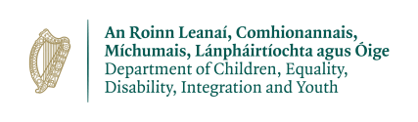

We are funded directly by Pobal, a government agency ([www.pobal.ie)](https://www.pobal.ie/), with close operational links with the Department of Children, Equality, Disability, Integration and Youth (DCEDIY). [http://www.gov.ie/en/organisation/department-of-children-equality-disability-integrationand-youth](http://www.gov.ie/en/organisation/department-of-children-equality-disability-integration-and-youth)

## Our Staff

We employ eight full-time and two part-time staff members. Full information about our staff is available at: <https://www.kccc.ie/Our-Members> See Appendix 2 – KCCC Salary Scales

## Our Governance

Kildare County Childcare Committee has adopted the Charities Governance Code.

See <https://www.charitiesregulator.ie/en>

We seek to offer transparency on all aspects of our organisation. Full information on all of the following areas is available on our website (click to follow links):

[**Our Board**](https://www.kccc.ie/Our-Members) **& Staff**: <https://www.kccc.ie/Our-Members>

[**Our Financial Records**](https://www.kccc.ie/Governance) **and Annual Reports:**<https://www.kccc.ie/Governance/>

[**Our Complaints Procedure:**](https://www.kccc.ie/Portals/0/CUSTOMER%20COMPLAINT%20PROCEDURE%20.pdf)<https://www.kccc.ie/Governance/Complaints>[**Our Privacy Policy:**](https://www.kccc.ie/privacypolicy)<https://www.kccc.ie/Privacy-Policy>

## Our Programme of Work

Our programme of work is set out in our Statement of Work 2023, provided by DCEDIY. KCCC work to complete this programme in line with our KCCC Strategic plan 2023-2026 and the First 5 policy, a government strategy to improve the lives of babies, young children and their families. We also have scope to perform additional actions as the need arises.

In 2023 KCCC supported 182 centre based services and 90 Childminders in Co. Kildare. Our multi-lingual team supported numerous parents to access childcare places and childcare subsidies. We supported an increase in our parent & toddler groups and provided outreach stay and play sessions in emergency accommodation centres throughout Kildare.

**Our work includes:**

* Supporting service with Compliance and finances including case management support
* Support services to maintain high quality childcare and education services both centre based and home based for children aged under 15 years.
* Plan, Facilitate, evaluate training and information sessions for educators, managers and childminders
* Support childminders through the National Action Plan for Childminding
* Support services to administer the national funding schemes and programmes and Support services to remain complaint with Pobal funding rules
* Provide information and/or data to DCEDIY or its agents arising out of the Review of the ELC and SAC Operating Model
* Support all parents to access information on childcare provision and national subsidies to enable all children equal access to ECCE programmes and Childcare & Education
* Promote and administer small capital grants as set out by DCEDIY
* Support parent and toddler groups
* Promote and offer support and guidance on the Access and Inclusion Model

Programme to support children in need of extra support in ECCE programme

* Support families and children affected by Ukraine Humanitarian Crisis
* Support services with Core Funding supply side funding to improve quality of the sector
* Support new services to develop and liaise with local authorities where appropriate

Work collaboratively with agencies at national, regional and local levels to support the KCCC to complete their Statement of Work in a holistic manner to support the childcare and education services and families in Kildare.

# Strategic Plan KCCC 2023-2026

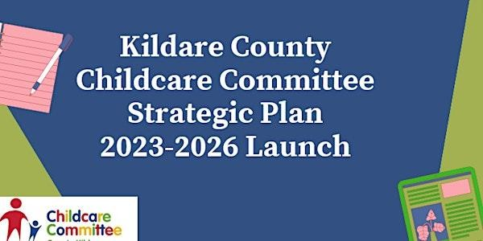On 6th March 2023, we launched KCCC Strategic Plan 2023-2026 in the Kilashee Hotel. There was 40 people registered and 20 attended including local counsellors, board members, KCCC staff, educators and community members with a keen interest in Childcare. The local press published photos and a press release from CEO.

The plan consists of 8 Strategic Aims:

1. Excellence in the local childcare and education sector
2. Building local capacity
3. Working collaboratively
4. Equal access and inclusion
5. Communicating with purpose
6. Childcare and childminding as a professional career choice7.
7. Our team
8. Delivering organisational success and effectiveness

The development of our Strategic plan with all key stakeholders including children offered time and space to reflect on how best we serve the sector and focused us to meet the emerging needs of children, families and childcare and education services post covid and midst a humanitarian crisis in a collaborative manner with other community support agencies. In 2023 we planned and completed a number of actions from our Strategic Plan. To name a few, KCCC recruited an Early Years Initiative Development Officer to support parents and babies under 3 years through offering support to parent and toddler groups and the volunteers who set up and sustain P&T groups. As a result our Parent and Toddler groups increased from 22 up to 30 in 2023. We provided a number of play and stay sessions with children and families in a number of emergency accommodation centers and offered information on Childcare and Childcare Subsidies to vulnerable families residing in these emergency accommodation centers. Additionally we had an appreciation event for service providers and educators in Kilashee Hotel for our 21st KCCC celebration event.

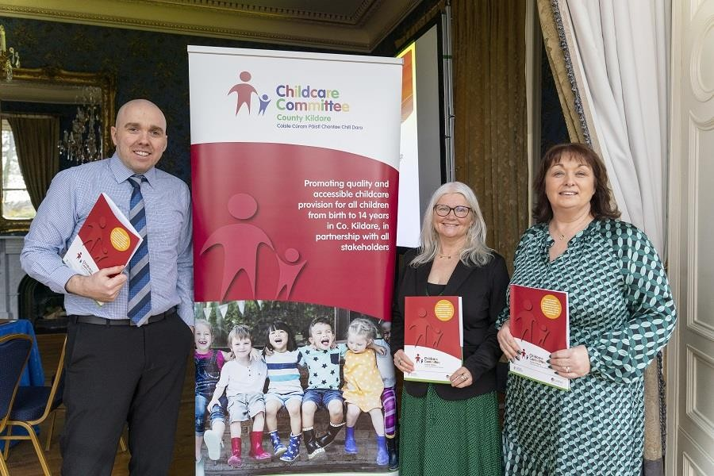

https://kildare-nationalist.ie/2023/03/14/survey-highlights-staffing-challenges-and-availability-ofchildcare-in-kildare/

# Kildare County Childcare 21st Conference

In April 2023, to mark KCCC 21st Anniversary, we hosted a Conference for the Managers/Owners of Early Childhood Education and Care settings including Childminders on: Saturday 22nd April 9.30am to 2pm in the Killashee Hotel, Naas, Co. Kildare.

On the day we introduced; as part of KCCC Strategic Goals; Restorative Practices (RP). This is an evidence-based set of skills that help develop and sustain strong and happy organisations

and communities. Read more about RP here: [https://www.cdi.ie/our-](https://www.cdi.ie/our-programmes/restorative-practices/)

[programmes/restorative-practices/.](https://www.cdi.ie/our-programmes/restorative-practices/) We had a raffle for 10 services to attend free Introduction To Restorative Practices with CDI.

Our Keynote speaker Dr. Sinead Kane shared her experiences and insights focusing on our Relationship with Self, drawing on Resilience, Mindset and Teamwork. Read more about Sinead here https://sineadkane.ie/.

38 people registered to attend our conference and we received positive feedback from 100% of attendees. KCCC also organised a lunch and appreciation packs for attendees in recognition for their service.

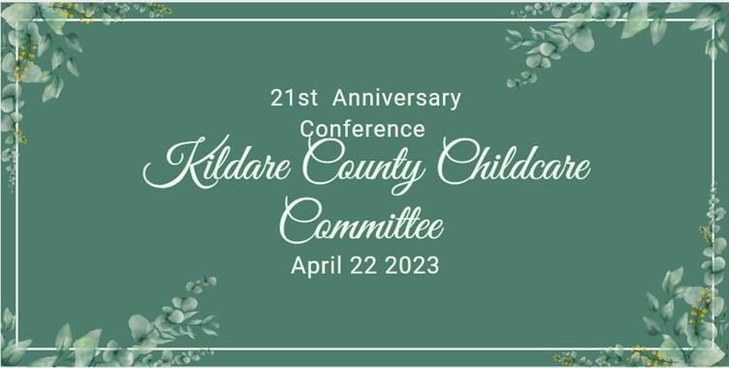

# Administration of Government Childcare Schemes

## National Childcare Scheme (NCS)

There was a large increase in participation for the NCS programme in 2023 with the government announcing a 90% increase in number of children benefitting from the programme. The department advised there were

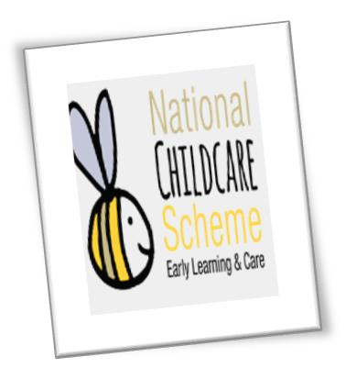134,580 children who benefited from supports under the National Childcare Scheme within the first six months of 2023. In January 2023, the minimum hourly subsidy for families using registered early learning and childcare is €1.40 per child this would give a up to a total of €3,276 in annual

out of pocket costs for early learning and childcare per child. For the income assessed subsidy which are means assessed and they are available to families on lower incomes families availing of this could see a reduction of up to a maximum of €8,775 per child.

In 2023 KCCC supported 8 families to access the sponsored NCS scheme eligibility to this strand is a special arrangement where a child can be referred by certain Statutory Organisations for an NCS subsidy where childcare is needed on child welfare, child protection, family support or other specified grounds. Unfortunately, due to the lack of availability of childcare, there have been cases where KCCC have not been able to place children including the most vulnerable children affected by homelessness, humanitarian crisis and families engaging with Tusla family supports. KCCC has develop links with the statutory organisations to endeavour to support parents through the application stage of this programme.

## Community Childcare Subvention Plus Programme (CCSP)

The CCSP is a legacy programme and only available presently to children who were registered for this prior to November 2019 and still retain their status with the Department of Social Protection. Each year the numbers reduce as children leave the programme due to age or move over to NCS.

## The Early Childhood Care and Education Programme (ECCE)

This programme is a universal two-year pre-school programme available to all children within the eligible age range 2.8 years- school age or 5.6 years.

It provides children with their first formal experience of early years education prior to commencing primary school. The programme is provided for three hours per day, five days per week over 38 weeks per year and the programme year runs from September to June each year.

There is one point of entry at the beginning of the programme year in August/September annually. The programme will be available to all children who have turned 2 years and 8 months of age before August 31st as long they won’t turn 5 years and 6 months of age on or before June 30th of the programme year.

Childcare services taking part in the ECCE programme must provide an appropriate pre-school educational programme which adheres to the principles of Síolta, The National Quality Framework for Early years Care and Education sector and implement; Aistear, the National Curriculum Framework for Early Childhood Care and Education Sector. There is a high level of children in Kildare partaking in this programme.

## Access and Inclusion Model Programme (AIM)

The ECCE programme offers the Access and Inclusion Model (AIM) is a model of supports designed to ensure that children with disabilities can access the ECCE Programme. AIM is a child-centred model, involving 7 levels of support, moving from the universal to the targeted, based on the needs of the child and the preschool service. KCCC offers support to services and parents to ensure the best use of this programme, there is currently a high uptake of places for this programme.

## Core Funding

This new funding model was introduced in 2022 it supports delivery of ELC and SAC for the public good, for quality and affordability for children, parents and families. To achieve this, there is a need for greater State investment and greater public management of provision. Core Funding is the new funding stream to start this partnership for the public good between the State and providers.

Core Funding is funding directly to providers (supply-side funding) and is designed improve affordability, quality, inclusion and sustainability. Core Funding operates alongside the NCS and ECCE and constitutes additional income for providers on top of funding for these schemes, as well as income from parental fees. KCCC offered 4 workshops one to one and 500 telephone support calls to services to support them in contracting for this funding programme. The majority of childcare services in Kildare have contracted for the Core Funding Partner Service Funding Agreement.

## Pobal Compliance

Pobal is contracted by the DCEDIY to conduct compliance visits with participating childcare Service Providers who operate one or more of the national childcare programmes. These national childcare programmes are:

* Early Childhood Care and Education (ECCE)
* National Childcare Scheme (NCS)
* Community Childcare Subvention Plus (CCSP) Saver Programme

All programmes are administered on the Hive (Early Years Platform). In 2023 Pobal Integrated Case Management (ICM) revised the process in 2023 and Kildare County Childcare Committees at the request of the Department of Children, Equality, Disability, Integration and Youth (DCEDIY) offer supports to non-compliant services and advise on rectifications with the given timeframes. KCCC offered further support to individual services before and after a visit. KCCC delivered 2 Pobal Compliance workshops in 2023 to support services identify, prepare and familiarise themselves to what was required to ensure their service had a positive compliance outcome. These workshops were attended by managers and staff of over 60 childcare services in Kildare.

Pobal is contracted by the DCEDIY to conduct compliance visits with participating childcare Service Providers who operate one or more of the national childcare programmes. These national childcare programmes are:

* Early Childhood Care and Education (ECCE)
* National Childcare Scheme (NCS)
* Community Childcare Subvention Plus (CCSP) Saver Programme

All programmes are administered on the Hive (Early Years Platform). In 2023 Pobal Integrated Case Management (ICM) revised the process in 2023 and Kildare County Childcare Committees at the request of the Department of Children, Equality, Disability, Integration and Youth (DCEDIY) offer supports to non-compliant services and advise on rectifications with the given timeframes. KCCC offered further support to individual services before and after a visit. KCCC delivered 2 Pobal Compliance workshops in 2023 to support services identify, prepare and familiarise themselves to what was required to ensure their service had a positive compliance outcome. These workshops were attended by managers and staff of over 60 childcare services in Kildare.

Childcare Service provision:

Kildare saw the permanent closure of 7 services in 2023 this was for various reasons of personal, retirement, change in career or due to registrations issues. Two of the closures were then taken over by existing staff members creating new ownership for September 2023. In 2023 Kildare CCC supported 7 brand new services opening of the first time which was welcomed by families in the county.

## National Aistear Siolta Initiative

**Aistear 0-3's** – In 2021, The National Council

for Curriculum and Assessment (NCCA) began a process to update Aistear, the Early

Childhood Curriculum Framework (NCCA, 2009) and that consultation is currently underway.

Phase 1 of the consultation was completed in December 2022, with Phase 2 beginning in

2023 and it is envisaged that an updated Aistear will be finalised in 2024. See [https://ncca.ie/en/early-childhood/early-childhood-education-developments/updatingaistear/](https://ncca.ie/en/early-childhood/early-childhood-education-developments/updating-aistear/) for more information.

In January 2023, training recommenced for the services in Co. Kildare. The Kildare CCC team delivered a total of 10 NSAI workshops consisting of 4 Introductory workshops and 6 Siolta Standards workshops with 39 participants from 26 services in attendance.

## Quality Support

Kildare CCC worked to support 20 services in 2023 with their CAPA response to Tusla Inspections and also collaborated with Better Start Quality Development Programme to support 1 service. Onsite visits commenced once again after the Covid-19 Pandemic and Kildare CCC supported 7 services, with a total of 12 onsite visits in 2023. These visits were in relation to quality support, compliance support and Parent and Toddler Group support.

Kildare CCC provided information and support to 29 potential providers with 8 of those becoming new services in 2023. Kildare CCC also supported all services in the county by supporting 13 services on a one-to-one basis with Tusla registration, 91 services with Tusla Re-Registration and 41 services received one to one support in relation to Change In Circumstances. 103 services received support with Regulatory Compliance and 25 services received one-to-one support with Policies and Procedures.

Onsite visits commenced after the Covid-19 Pandemic and KCCC supported 7 services, with a total of 12 onsite visits in 2023. These visits were in relation to quality support and compliance support.

KCCC team became a restorative team after completing the Restorative Practices training with the whole team in January 2023.

## Children First Training

Kildare CCC is committed to the full delivery of the National Always Children First Plan as it is imperative to ensure better outcomes for

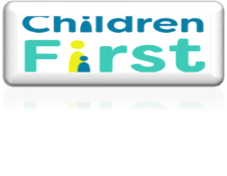children. It is Kildare CCC’s aim to have all Early Years services trained in safeguarding, developing a safeguarding culture and developing robust policies and procedures.

Following the introduction of Mandatory reporting in 2018, KCCC continued to offer updated training to childcare services. Services were continued to be advised, by way of our regular email bulletins, to refresh their knowledge through repeating the online Always Children First e-learning programme. In 2023, there was also the introduction of the Mandated Person and DLP e-learning programmes. In 2023 Kildare CCC held a total of 6 Always Children First Child Safeguarding Foundation Training sessions. There were 79 participants in these sessions.

## AIM

The Access and Inclusion Model (AIM) is a model of supports designed to ensure that children with disabilities can access the ECCE Programme. Its goal is to empower pre-school providers to deliver an inclusive pre-school experience, ensuring that every eligible child can meaningfully participate

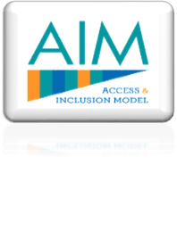in the ECCE Programme and reap the benefits of quality early years care and education. AIM is a child-centred model, involving seven levels of progressive support, moving from the universal to the targeted, based on the needs of the child and the pre-school service. KCCC have responsibility under their AIM budget to deliver actions under the Universal supports aspect of the model to include the following:

* the provision of information on AIM, including leaflet distribution, mailshot and the provision of information sessions to providers/parent’s associations and other local networks where requested,
* the Provision of phone support for parents and providers and support with applying for supports through the PIP system,
* co-ordination and delivery of the Diversity, Equality and Inclusion Training,
* the provision of support to Pobal, as required, in relation to levels 5 and 7, and
* to engage with the level 3 training, as required, including the co-ordination of training and the delivery of some training.

In 2023, we hosted an information session in relation to AIM for Parents and also one for Services. We promoted AIM supports to all parents on our mailing list and we supported 18 parents who had difficulty in accessing AIM places.

We promoted AIM supports to all childcare providers in Kildare, assisting 22 services to engage with AIM for the first time and supporting 57 services to understand the AIM rules and 80 services receiving AIM information and supports.

**Equality, Diversity and Inclusion Training;** the Equality, Diversity, and Inclusion Charter, developed by DCEDIY, aims to empower professionals in the sector to embrace and implement inclusive practices for the betterment of children, families, and society at large. Through EDI training, providers gain insight into the charter and guidelines, create their own inclusive charters for their respective settings, and cultivate an anti-bias approach in early childhood contexts, among other essential skills.

In 2023, Kildare CCC delivered 4 EDI training sessions to 25 participants from 17 different ELC and SAC services.

## Manager Networks

Kildare County Childcare Committee invited managers and owners to partake in a managers’ network in March 2023 there were 13 who attended on the evening which was facilitated by KCCC staff they feedback was that they would like to have a mix of online and in person events with a topic going forward that would support the running of the childcare service.

In May KCCC hosted an online event with Workplace Relations Commissions Information and Customer Services team to host a presentation with an overview of employer’s responsibilities, this online event was attended by 10 services.

In September KCCC in collaboration with the Tusla Meitheal Team to advise services in Kildare on the Meitheal approach to help children where they may need the support of more than one service. Meitheal is a case coordination process for families with additional needs who require multi-agency intervention but who do not meet the threshold for referral to the Social Work Department under Children First. This event was in person and held in Lawlor’s hotel, 27 service enrolled to attend the session which was very interactive and informative.

# Grants

## The Childminding Development Grant

The grant is designed to assist Childminders, already providing a childminding

service in their own homes, to enhance safety/quality in the service through the purchase of small capital items, equipment, toys or minor adaptation costs. In 2023 the Childminding Development Grant was reviewed and updated making it more accessible to all potential and existing childminders nationally. The maximum award for the grant is currently €1000.

In 2023, the CMDG application process was administered centrally by Sligo CCC. The grant was promoted locally by Kildare CCC on Facebook, our Website and by email to all childminders on our mailing list. All childminders contacting Kildare CCC were supported with their application by our dedicated Childminding Development Officer and 8 childminders received the grant.

## The Parent & Toddler Grant

The focus of the 2023 Parent and Toddler grants was to support groups to include all families. This special focus asked local groups to include recently arrived parents and children from Ukraine and other countries. Parent and Toddler Groups provide informal support to parents, grandparents and childminders, as well as to young children. These groups are an important source of social contact especially for new parents and families new to an area.

Kildare CCC worked directly with P&T Groups in the administration of the grants in 2023. The grant scheme for P&T Groups was operated on an agreed grant cycle and timeframe, and in accordance with agreed national criteria and an approved assessment process.

Applications for funding under this scheme could only be made by P&T Groups that are organised on a not-for-profit basis and involve the participation of parents/guardians in the community.

In 2023 Additional funding was available for the following:

1. Additional P&T session; additional funding of up to €300 was available for new or existing P&T Groups providing an additional P&T session. The intention of the additional session was for new/additional parents/guardians to attend. This funding was aimed at, but not exclusively for, the possible inclusion of recently arrived parents and children from Ukraine and other countries living in the local community.
2. Buggy Walking Group; additional funding of up to €300 was made available for new or existing P&T Groups to establish and operate Buggy Walking Groups. Buggy Walking Groups are organised social walks for parents, guardians, and their babies and toddlers. They provide a range of benefits including social interaction, physical activity and emotional, peer support.

A total amount of €11,672 was awarded to 14 Parent and Toddler groups in 2023.

## Learner Fund Bursary

The Learner Fund for 2023 had two bursaries;

Graduate bursary – For new graduates of a recognised Early Childhood Education and Care degree programme (Level 7/8/9). The qualification must be;

1. On the DCEDIY Early Years Recognised Qualifications list and indicated as meeting the qualification requirements for lead educator graduate premium or
2. The applicant must hold a letter of eligibility to practice from DCEDIY which states that the qualification meets the standard for graduate premium.

Childminder bursary – For Childminders who are registered with Tusla and hold a Level 5 or Level 6 award on the National Framework of Qualifications (NFQ).

Since its establishment, over 5,000 early years educators have been supported to raise their qualification levels in Early Childhood Education and Care in line with the NFQ.

In 2023 Kildare County Childcare Committee approved 15 applicants who applied for the learner fund Graduate bursary and all were awarded €750 each in 2023. KCCC promoted the Childminder learner Bursary on social media and sent it to our 70-90 childminders on our mailing list, however no childminders applied in 2023.

# Childminder Supports

## National Action Plan for Childminding

The Steering Group of the National Action Plan for Childminding (NAPC) was formed in September 2021,

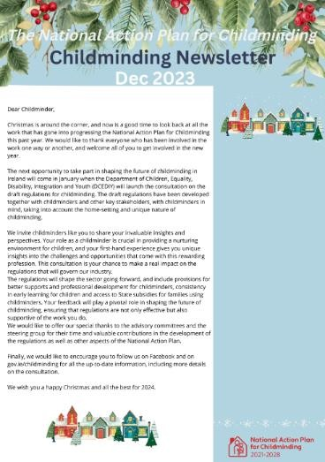following the publication of the NAPC in April of that year. The Steering Group’s overall purpose is to drive, oversee and monitor the implementation of the National Action Plan for Childminding 2021 – 2028. The Steering Group’s Terms of Reference require it to provide an annual progress report to the Minister for Children, Equality, Disability, Integration and Youth. NAPC Phase 1 began in April 2021 and is due to end in autumn 2024 when childminding-specific regulations come into effect and registration opens to all childminders.

KCCC shared national seasonal Childminding Newsletters to 70-90 childminders on KCCC mailing list throughout 2023 4 times. KCCC team aim to support childminders in keeping up to date with new and positive changes including support for childminders as part of the National Action Plan for Childminding. KCCC also shared

information on Child-minding Little Libraries initiatives online using social media and via email to our childminders mailing list.

Childminding Training:

KCCC Childminding Development Officer supported the development of Childminding Tax workshops with the National Childminding Development Team and Local Enterprise Office accountant.

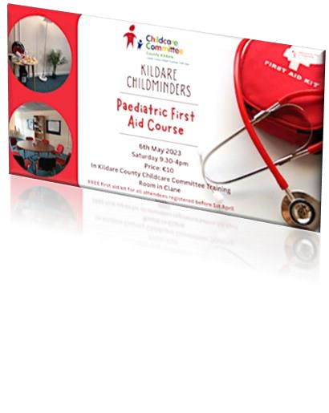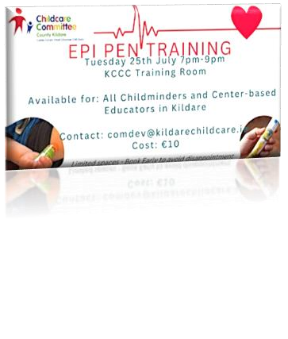KCCC funded First Aid training and First Aid kits for childminders in Kildare, 14 childminders registered and 12 attended. The childminders offered positive feedback on the training and requested Epi pen training as a follow on training.

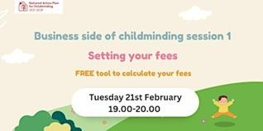

KCCC facilitated Epi pen training and 12 registered and 12 attended from childminding and center based services.

KCCC provided information sessions on the Business Side of Childminding for childminders in collaboration with other CCCs. 24 childminders registered and 19 attended. These sessions included information on how to, Set your Fees, Develop Childminding contracts with parents, Registration with Revenue.

Additionally, 6 childminders registered for other trainings offered to center based childcare providers including NSAI, ACF and EDI training.

Childminding Staffed Local Networks:

KCCC CMDO meet with Dr. Sheila Garriety on November 13th 2023 alongside regional CMDO team. The establishment of Staffed Local Networks (SLN)for childminders is one objective of the National Action Plan for Childminding, proposed as a means to enhance the quality of provision for children and families, while encouraging childminders to engage with formal supports, and in time, regulatory services. KCCC participated in SLN research undertaken through 2023 aimed to document and make observations regarding the support and development of locally based childminding networks. Research partnership, made up of members of the UNESCO Child & Family Research Centre at the University of Galway, and national lead actors at the Department of Children, Equality, Disability, Integration & Youth (DCEDIY) responsible for progressing the NACP. A participatory action research methodology engaged with Kildare Childminding Development Officer and other CMDOs employed nationally in local City/County Childcare Committees (CCCs). The study was supported by a Research Advisory Group (RAG), made of the Principal Investigator (PI) and national lead actors in the NAPC. Through 2023 ongoing engagement among CMDOs, and between the PI and CMDOs, guided at all times by the RAG, underpinned a process of collaborative data generation and co-constructed meaning making.

As part of this research KCCC CMDO, facilitated 8 monthly Connecting Childminders informal network events for childminders in Kildare locally. These were hybrid meetings in person in

KCCC training room and accessibly online too. 28 childminders registered and 11 attended. These meetings were facilitated using a hybrid model, some childminders attended online and some attended in person.

KCCC facilitated 7 monthly online “Introduction to Childminding” information session for childminders 16 registered and 10 attended.

KCCC provided a one stop shop Childcare and Education Fair for childcare and education sector including childminders. Childminding Ireland attended alongside 12 other community support organisations and center based providers. Three childminders attended the event and the feedback from the event was positive.

Childminders also attended KCCC 21st Conference and had the opportunity to engage and network with center based and childminder professionals.

KCCC CMDO facilitated two network events for childminders and children for Christmas in libraries in South Kildare. There was huge interest in these sessions 20 childminders registered and 6 childminders attended. This also gave an opportunity for childminders to engage with this local libraries as stated as a priority in First 5 policy.

# Communications

Our Communications strategy acknowledges the diverse communication needs of all our individual stakeholders. Therefore, we utilised many forms of communicating, including online and electronic media, phone calls, emails, and text messages with our target groups, including Childcare & Education Services, parents and childminders, community agencies. KCCC provided regular communication with services, regarding compliance, funding and support, grants were conducted through our usual email bulletins and Facebook posts.

* In 2023 we sent out 45 Childcare Bulletins to services in Kildare.
* We maintained a strong social media presence on our social media channels including our [website,](http://www.kccc.ie/) [Facebook,](http://www.facebook.com/kildarechildcare) and [Instagram.](http://www.instagram.com/kildareccc)
* We shared 424 Facebook posts in 2023, with a reach of 29,300 with content interactions of 1.1K on Facebook overall. We had 3000 people following our page.
* We had 44,930 visits to our website in 2023.

# Events

54 events were advertised and attended in 2023, the events included EDI, AIM, First Aid, Children First Training, and a number of essential information sessions to support the services.

# Recruitment Support

In June 2023 KCCC in collaboration with South Dublin CCC hosted a "Business Support Upskilling Recruitment Event" the event took place in Leixlip. Support and training agencies around the county were invited to host a stand at the event to give information on the supports that they offer it was attended by Citizen’s information Kildare, Leader Partnership, Canavan and Byrne, South East Technology University, Workplace Relations Commission (WRC), DEASP Department of Social Protection, NUIM National University Maynooth, Education and Training Board, LINC, Citizen’s information, Kildare Leader Partnership, Childminding Ireland, Kildare Local Enterprise Office. Invitations were sent to all childcare services, childminders and students to offer the options of all information on all the business supports that are available to them along with training and job opportunities. Childcare services from both Kildare and South Dublin hosted stands to offer employment opportunities to attendees on the day. The DEASP extended the offer to all clients on the live register to offer the opportunity of a career in the childcare sector of childminding.

KCCC continue to offer to all service the option to send job vacancies to be advertised on the KCCC website. KCCC continued to link with the DEASP to offer services the option of have their vacancy posted on the Jobs Ireland website<https://jobsireland.ie/>and advertised in all INTREO Centres, circulated to the DEASP Case Officers and partner organisations and matched to suitable job seekers they may have registered on their system. KCCC staff attended a recruitment event in the DEASP centre, in July 2023 where local childcare services were invited to attend and host a stand on the day.

# Ukraine Support

Our multi-lingual information officer worked with Ukrainian parents in accommodation centers and with parents who are living in the community. Some of the services offered are listed below:

* contacting child care services to find places
* offering visits to accommodation centers
* providing phone supports and signposting to services
* offering a meet and greet session
* distribution of My Place to play packs
* providing information in Ukrainian about childcare services and types of subsidies
* Providing information about Parent and Toddler groups in the area and encouraging parents to attend the groups
* Support with forms and applications
* distributing ECCE packs for children
* supporting setting up of Parent and Toddler groups

In 2023 the total number of interactions for support to Ukrainians was 323. The total number of childcare places arranged: 12 ( including 3 Sponsored Referrals places and ECCE). 42 children could not access childcare and were placed on a waiting list. This work required sensitivity and patience as families got used to their new lives in Ireland. The role is evolving as the number of accommodation centers in the county increases.

Ukraine Independence day celebrations event took place in August in Newbridge, to celebrate the Ukrainian Independence Day organized by the County Kildare Leader Partnership. Over 250 Ukrainians attended the event. KCCC Information Officer attended the event and offered advice on how KCCC can support families affected by the Ukraine Crisis to help children to access childcare in Kildare and accessing childcare subsidies.

Our Information Officer met Ukrainian parents in our offices in Clane. There were 5 attendees from Liffey Lodge in Newbridge. Information leaflets were provided in Ukrainian. There was also a visit to Ukrainian families in Liffey Lodge in November. Over 50 parents attended. A brief information session was given on the local childcare services.

# Collaborations with Local and National Networks

In 2023 KCCC collaborated with the following local and national agencies.

**Childcare Committees Ireland (CCI),** the National representative group of the 30 County and City Childcare Committees

⬥ **Parenting Forum & parentingsupport.ie;** providing information on parenting supports and services in Kildare and West Wicklow to support the development of parentingsupport.ie webpage for signposting parents

⬥ **Social Inclusion and Community Activation Programme (SICAP);** administered by Pobal SICAP provides funding to tackle poverty and social exclusion through local engagement and partnerships between disadvantaged individuals, community organisations and public sector agencies. KCCC collaborated on the SICAP review and new strategic plan for SICAP.

⬥ **Children and Young People’s Services Committees Kildare (CYPSC);** county level committees that are key structures identified by Government to plan and co-ordinate services for children and young people in every county in Ireland. The overall purpose is to improve outcomes for children and young people through local and national interagency working. Includes CYPSC outcome groups and the direct provision working group. KCCC collaborated with CYPSC working with a researcher to map the provision of childcare in Kildare. KCCC also engaged with the new CYPSC strategic plan and attended the launch in Newbridge alongside a number of community support agency members.

⬥ **National Traveller and Roma Inclusion Strategy;** KCCC is a member of steering group and attend regular interagency meetings to support the travelling and Roma communities to access equal opportunities to access ECCE. KCCC are currently engaging with the Travelling and Roma communities to establish a parent and toddler group in their communities.

⬥ **Department of Employment Affairs and Social Protection (DEASP);** and Intreo centres in Kildare. KCCC attended recruitment events organised by DEASP to promote the recruitment of new Educators into the sector.

⬥ **Early Childhood Ireland (ECI);** the largest organisation in the early years sector representing 3,800 childcare members, who support over 100,000 children and their families through preschool, afterschool, and full day-care provision nationwide. Their work includes quality enhancement, publications, advocacy, training, business support & information for the ELC and SAC sector. ECI representative attended our KCCC 21st Conference in March 2023.

⬥ **Infant Mental Health Network (IMH);** a network that provides a reflective practice space to support expertise and knowledge in the area of IMH to practitioners and managers working with infants, young children and their families. KCCC worked in collaboration with IN SYNC to maintain the IMH in Kildare with the hope to join the network in the future.

⬥ **Tusla;** the Child and Family Agency that is the dedicated State agency responsible for improving wellbeing and outcomes for children. KCCC worked closely with Tusla to support vulnerable children to access childcare under NCS sponsorship.

⬥ **CFSN;** Tusla’s network of Child and Family support services. KCCC team attended quarterly CFSN meetings in south and north Kildare. CFSN coordinators also provided an information session on Meitheal for Managers network and 22 attended the event.

⬥ **Barnardo’s;** Ireland’s children's charity. KCCC staff attended Barnardos training in 2023.

⬥ **Kildare and Wicklow Education and Training Board (KWETB);** who provide a comprehensive range of education services throughout Kildare and Wicklow. KCCC worked in collaboration with KWETB at our Childcare and Education Fair event. An ETB representative attended the event to share information on ELC new childcare course available in Kildare in 2023.

⬥ **Childcare Infrastructure Group;** a collaboration with CYPSC, KCCC, Kildare County

Council and Tusla addressing problems around lack of availability of childcare provision and premises in Kildare. KCCC worked collaboratively and actively to support research on the childcare provision in Kildare alongside the CSO new data to proactively support the needs of childcare provision based on the needs of the children in the county.

⬥ **Local Enterprise Office;** a collaboration with Childminding Development Officers in KCCC and Westmeath CCC to develop a registration with revenue information session for childminders over the region of 6 counties. LEO representative also attended our Childcare and Education fair to offer information on the supports available to small- medium childcare providers including childminders in Kildare.

## ⬥ **Mother Tongues Language Explorers**

**Programme for ECCE services in Kildare;** Kildare CCC partnered with Mother Tongues to pilot a programme aimed at promoting and nurturing multilingualism in early childhood settings. Targeting 10 interested services, Kildare CCC and Mother Tongues organised an initial online information session to outline programme details and participation requirements. Subsequently, an artist from Mother Tongues visited each service to engage both staff and children in enriching activities. The programme concluded with a final online session for feedback and additional support. Throughout the initiative, comprehensive information and assistance were provided to early years services and their staff.

⬥ **Local Community Development Committees;** (LCDCs) are groups established in each local authority area. An LCDC is made up of: members of the local authority, local authority staff, people from public bodies who provide funding to the area, people from the local community interests, people from the local community, people from publicly funded/supported local development groups. LCDCs draw on the expertise and experience of public and private people and organisations in each local authority area. KCCC team engaged with the LCDC Co Ordinator to discuss the Childcare needs of childcare providers and families in Kildare. The need for more childcare provision and more community supports for development of community childcare provision was noted in the current Local Economic and Community Plan.

⬥ **Community Response Forum;** Local community and voluntary groups around the country have been mobilising in recent weeks to welcome into their communities people who are fleeing Ukraine. As the new arrivals begin to settle in, each local authority has established a Community Response Forum to provide a co-ordination point for the community and voluntary response in their area. KCCC team lead attended all community response forum meetings and supported children and families in emergency accommodation with outreach support including , stay and plays, external play facilitator events, information sessions for parents to access information to access ECCE and NCS sponsorship.

# Kildare Healthy Ireland Early Years Development Initiative

## Kildare CYPSC and Kildare County Childcare Committee collaboration

Parent and Toddler groups have traditionally been a vital peer support for parents, many stopped over covid and need a lot of support to restart as they are mostly volunteer led.

KCCC are often contacted by social workers and public health nurses looking for P&T groups when they are supporting a family as they recognise the value of this peer support. This can be even more valuable for parents from new communities, those experiencing homelessness or living in emergency accommodation.

There was a drop in the number of Parent and Toddler groups in Kildare, from 41 in 2017 to 5 in 2020, due to Covid closures and difficulties reopening (most did not reopen for a year or two if at all). We are slowly building these back up, with 22 listed early this year (this has now increased to 30 by the end of 2023).

**Types of supports offered to parent and toddler groups:**

* Phone and email support, support visits from the EYI Development Officer.
* Assistance with financial planning for groups, volunteer recruitment, finding suitable premises.
* Advice on play and child development and on planning of activities in groups.
* Information for parents on accessing childcare, ECCE and the National Childcare Scheme (government financial assistance for childcare costs).
* Assistance with grant applications and reporting, (14 groups availed of the Parent and Toddler grant this year). Financial assistance for new groups who have missed grants.
* Advice on child safeguarding for groups.
* Other issues as they emerge.

Our Development Officer worked at identifying gaps in provision: for example in areas of high population where there is no existing group, developing links in the community to get these started.

In 2023, 27 groups have received support, with 13 support visits completed. Intensive support has been provided to 6 groups, 2 of whom were new groups and 3 who were having difficulties / closing down. 5 of these are now meeting regularly, 3 of these are still receiving ongoing support. 1 is still in the setup phase.

Planned new groups: Celbridge – linking with KCC community worker, local community centre on reestablishing a group in the town. This is an area with lots of young families, there is also a large accommodation centre in the town so it is a priority area. Roma Parent and Toddler group – Early 2024 - linking with KLP and Newbridge FRC on this. Traveller Parent and Toddler group – Early 2024- linking with KTA on new group.

**Emergency accommodation / direct provision centres:**

* These are receiving direct supports in the set-up of play areas and establishment of Stay and Play sessions for parents with young children.
* Pilot in Celbridge Manor hotel – 1 meet and greet session attended, play room established and 24 Stay and Play sessions have been provided. These have been attended by Roma families, families who are homeless and those who are seeking international protection.
* This offers children a place to play outside of their rooms and parents a chance to interact with their children in a relaxed, play based environment. Signposting on childcare, ECCE and National Childcare scheme is also provided to these parents regularly.
* Also provision of other activities over summer and school holidays (collaboration with Kildare Libraries, CYPSC, KLP, Kildare Sports partnership on these).
* Also linking with the Eyre Powell hotel in Newbridge, Hazel hotel in Monasterevin and Kill accommodation centre.

I am Baba is a theatrical performance for babies from Anna Newell theatre company.

15 performances over 5 days in October, 3 each in Newbridge, Athy, Naas, Leixlip and Allenwood. 77 parent and baby pairs took part . This was a great collaboration with local Family Resource Centers and community groups.

We received wonderful feedback both from parents and from the hosts, helped parents to link in with services, parent and toddler groups.

My Place to Play is a play mat for babies living in cramped / emergency accommodation. These come with developmentally appropriate toys and involve a short session with the parent reinforcing the benefits of tummy time and quality interactions with their baby.

Training attended, 19 mats distributed to families around the county – including directly in accommodation centres, with Peter McVerry trust, and Family resource centres.

# Additional Work of KCCC

KCCC in conjunction with SETU (South East Technological University) hosted an information evening for potential students in the childcare sector regarding the **Early Childhood Level 7 degree/ Level 8 honours degree and Masters running in September 2023 and the funding options that would be available.** The session focused on year 1 entry to Level 7 & level 8 degrees, advanced entry to year 2 of level 7 & Level 8 degrees for those who held a QQI Level 6 major awards in Childcare, with progression for those who have a Level 7 degree to Level 8 honours degree and details on the Masters programme. There was a large interest and 30 potential students attended the session.

# Finance

KCCC’s main funder is the Department of Children, Equality, Disability, Integration and Youth (DCEDIY): In 2023 KCCC received DCEDIY Core funding of **€488,149.** The total Salary costs for 2023 were **€384,566**, our Administration Overheads amounted to **€96,364** andCore Work Programme Costs amounted to **€7,219.**

* The AIM budget for 2023 was **€23,625.** This was spent on salaries, administration and programme costs in relation to AIM.
* The EDI budget was **€10,000**.
* **€73,000** funding was received for the Childminding Development Officer
* **€11,250** was awarded to successful applicants under the Learner Fund bursary.
* was received under the Parent and toddler grants funding received was **€11,672** and this was allocated to successful applicants.
* **€2,500** was received under the National Childminding Action Plan**.**
* **€1,500** was received for the National Síolta Aistear Initiative
* ➢ **€22,000** was received for Core Funding Supports.
* **€30,451** was received for Ukraine Response Supplementary funding.

The various budgets were monitored monthly and were included in the financial report at each board meeting. The financial report for the board includes:

* + Actual expenditure against planned budgets is compared on a monthly budget report
  + Financial Impact report
  + Master List of Grants received, spent and remaining.
  + Bank reconciliation
  + Credit Card spending report
  + Direct Debit report

Compliance with all legal and funder reporting requirements are adhered to and form part of the CEO report to the Board.

An appraisal committee assessed applications for small grants before being brought to the board of directors for final approval.

Quarterly financial returns were submitted to Pobal within the designated time frame.

KCCC’s full unabridged accounts for 2023 were given in draft form to the Finance, Audit and Risk Sub-Committee before being presented to the full Board of Directors at the AGM.

The audited financial statements are submitted to the Companies Registration Office alongside the annual return.

KCCC is registered with the Revenue Commissioners and operates PAYE/PRSI/USC in respect of all employees. Travel and Subsistence current rates are in line with Civil Service rates and included in our internal financial procedures.

Remuneration of all Staff is aligned to the Local Authority Grades 8 to 3. A defined pension scheme is provided by Zurich Life Assurance plc.

KCCC makes an employer’s contribution of 10% to staff pensions.

An apportionment policy was adopted in 2019 and continues to be implemented in 2023.

A comprehensive analysis of KCCCs funding is available in the company’s audited financial statements. These statements are available on our website [www.kccc.ie/Governance.](http://www.kccc.ie/Governance)

# Board of Directors Report

The Board is the governing body of KCCC. It is required to satisfy that the appropriate systems, procedures and practices are in place and for the management of the performance of the CEO.

The Board is required to act on a fully informed and ethical basis, in good faith, with due diligence and care and in the best interest of KCCC, having due regard to its legal responsibilities and objectives. It is the responsibility of the CEO to ensure that the Board is provided with the necessary information to enable it to perform its functions.

## Board of Directors Attendance 2023

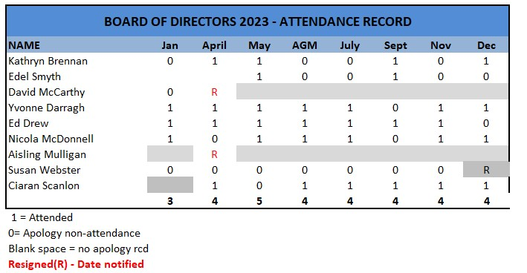

**Kildare County Childcare Committee held its most recent AGM on 13th July 2023.**



## KCCC Organisational Structure

Kildare County Childcare Committee CLG is a company limited by guarantee and not having a share capital. The company has charitable status for tax purposes and is registered as an employer.

|  |  |  |
| --- | --- | --- |
|  | **List of Directors and relevant experience** | |
| Ed Drew | Chairperson | Development Management |
| Edel Smyth | Company Secretary | PR & Quality Assurance |
| Yvonne Darragh | Director | Childcare |
| Ciaran Scanlon | Director | Finance |
| Nicola McDonnell | Director | Human Resources |
| Edelle McMonagle | Director | Public Relations |
| Raymond Fullam | Director | Finance/Accountant |
| David McCarthy* | Director | Finance |
| Kathryn Brennan* | Director | Compliance |
| Susan Webster* | Director | Legal |
| Aisling Mulligan* | Director | Legal |

*Resigned in 2023.

# Health, Safety and Wellbeing

A Health, Safety and Wellbeing committee was established in 2022.

* Health, Safety and Wellbeing is an agenda item at meetings of the Board of Directors
* The Kildare County Childcare Committee Safety Statement is reviewed annually and updated to ensure it remains fit for purpose.
* A risk assessment is in place.

Staff training for 2023 included First Aid Responder training and refresher; Manual handling training, Ergonomics and DSE training, Fire Warden training.

# Appendices

Appendix 1 – **KCCC Organisational Chart 2023**

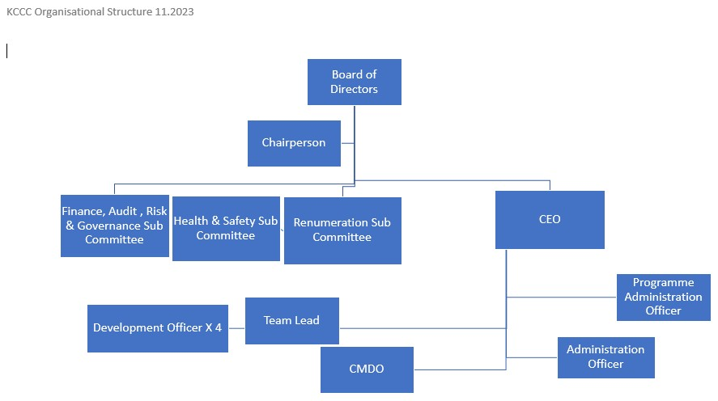

Appendix 2 – **KCCC Salary Scales**

Childcare Committee Salary Scales are aligned to local authority salary scales, which were as follows as at 1st March 2023; source Forsa.ie.

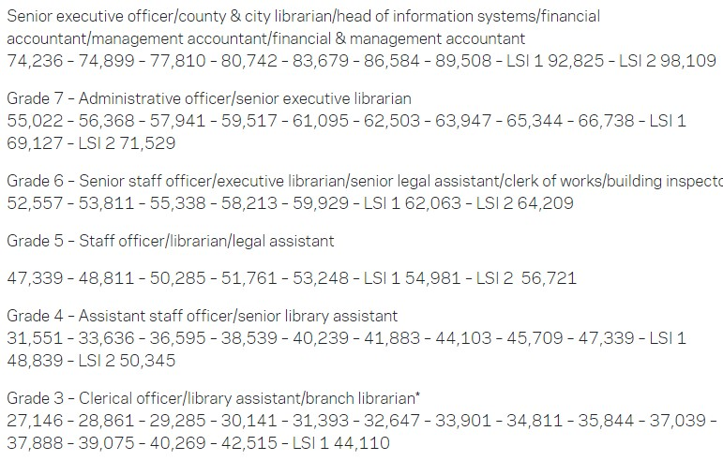

**facebook.com/kildarechildcare**



**instagram.com/kildareccc**

**twitter.com/KildareCCC**

**www.kccc.ie**

**Kildare County Childcare Committee**

**Address:** Unit 21, Thompson Enterprise Centre, Clane Business Park, College Road, Clane, Co. Kildare **Eircode**: W91 E6NY

**Tel:** 045 861307 **Email:** info@kccc.ie **Web**: [www.kccc.ie](http://www.kccc.ie/)

RCN: 20054175 CRO: 35591 CHY: 15585

**Chairperson:** Ed Drew

**Directors:** Ed Drew, Edel Smyth, Yvonne Darragh, Nicola McDonnell, Ciaran Scanlon, Raymond Fullam, Edelle McMonagle. **Company Secretary** Edel Smyth

 